**Basic Mechanical Engineering**

1. Minimum Number of links in kinematic pair and kinematic chain are ___ and ___respectively.
   1. 1,2
   2. **2,4**
   3. 4,4
   4. 2,2
2. The flywheel ...
   1. Reduces the fluctuation of power
   2. Maintain speed constant
   3. **Reduce the fluctuation of speed**
   4. Increase the efficiency
3. Which of the following is positive transmission drive
   1. Chain drive
   2. Belt drive
   3. Gear drive
   4. Rope drive
4. **A and C**
5. B and C
6. B , C and D
7. All of the above
8. Which type of chuck is used for eccentric machining:
   1. Eccentric chuck
   2. 3 Jaw chuck
   3. **4 Jaw chuck**
   4. All of the above
9. Which of the following bearing has low load capacity ?
   1. **Ball Bearing**
   2. Needle Bearing
   3. Sliding contact bearing
   4. Tapered Bearing
10. CNC represents
    1. Computerised Numerical Co-ordinates
    2. **Computerised Numerical Control**
    3. Computation Numerical Control
    4. Computational Numerical Center
11. Find the RPM of gear 3, if gear 2 rotates at 300 RPM.

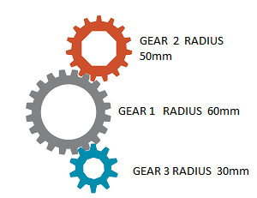

* 1. 400 RPM
  2. 600 RPM
  3. **500 RPM**
  4. 750 RPM

1. Which of the following is used to connect two eccentric shafts?
   1. Universal Coupling
   2. Split Muff Coupling
   3. **Oldham’s Coupling**
   4. Flexible Coupling
2. In case of 2-stroke engine, which of the following processes occur in first stroke?
   1. Suction and Exhaust
   2. **Suction and Compression**
   3. Suction and Power
   4. Power and Exhaust
3. Identify ‘1’ in the following fig.
   1. Gas Shield
   2. Slag Coating
   3. **Flux Coating**
   4. Insulation Coating

